Nama : Meuthia Bronthe

NIM : 09010182327012

Kelas : MI3A

Mata Kuliah : Praktikum Jaringan Komputer

STATIC

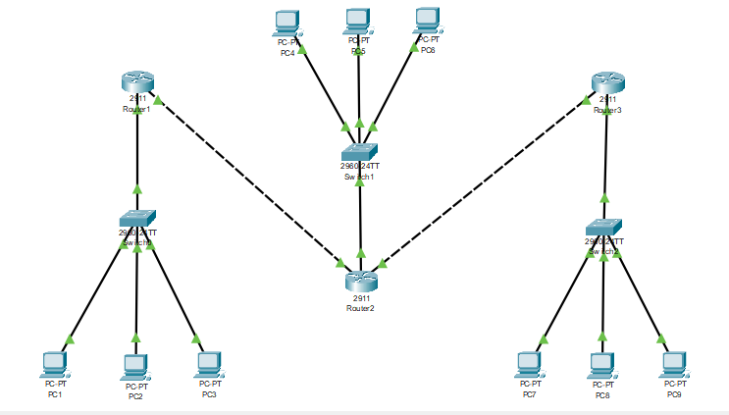

Router 1

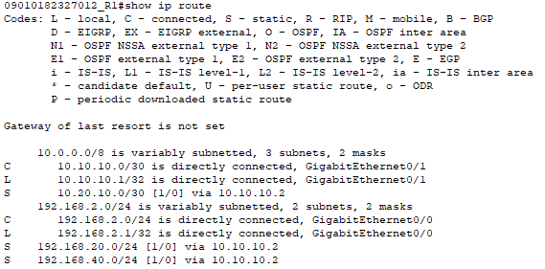

Router 2

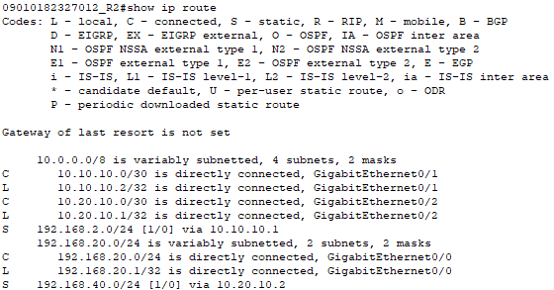

Router 3

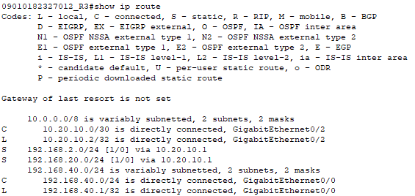

Tes Koneksi ICMP

|  |  |  |  |  |
| --- | --- | --- | --- | --- |
| **No** | **Sumber** | **Tujuan** | **Hasil** | |
| **YA** | **TIDAK** |
| **1** | **PC 1** | **PC 2** | **YA** | **-** |
| **PC 3** | **YA** | **-** |
| **PC 4** | **YA** | **-** |
| **PC 5** | **YA** | **-** |
| **PC 6** | **YA** | **-** |
| **PC 7** | **YA** | **-** |
| **PC 8** | **YA** | **-** |
| **PC 9** | **YA** | **-** |

|  |  |  |  |  |
| --- | --- | --- | --- | --- |
| **No** | **Sumber** | **Tujuan** | **Hasil** | |
| **YA** | **TIDAK** |
| **1** | **PC 4** | **PC 1** | **YA** | **-** |
| **PC 2** | **YA** | **-** |
| **PC 3** | **YA** | **-** |
| **PC 5** | **YA** | **-** |
| **PC 6** | **YA** | **-** |
| **PC 7** | **YA** | **-** |
| **PC 8** | **YA** | **-** |
| **PC 9** | **YA** | **-** |

|  |  |  |  |  |
| --- | --- | --- | --- | --- |
| **No** | **Sumber** | **Tujuan** | **Hasil** | |
| **YA** | **TIDAK** |
| **1** | **PC 7** | **PC 1** | **YA** | **-** |
| **PC 2** | **YA** | **-** |
| **PC 3** | **YA** | **-** |
| **PC 4** | **YA** | **-** |
| **PC 5** | **YA** | **-** |
| **PC 6** | **YA** | **-** |
| **PC 8** | **YA** | **-** |
| **PC 9** | **YA** | **-** |

PC 1 -> PC 5

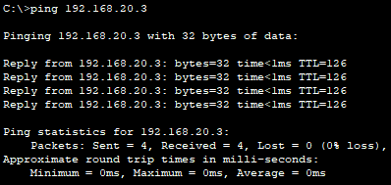

PC 1 -> PC 5

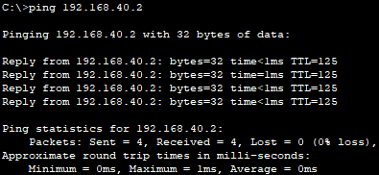

PC 4 -> PC 2

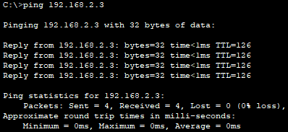

PC 4 -> PC 8

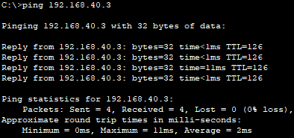

PC 7 -> PC 3

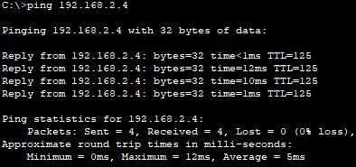

PC 7 -> PC 9

